

The Third Sunday of Easter

CHRIST LUTHERAN CHURCH | Lodi, California
April 19, 2026

WELCOME TO WORSHIP
Welcome to Christ Lutheran Church. We pray that your soul will be strengthened by the good news about God’s grace, love, and forgiveness given to us. If you would like to learn more about our church, please speak with our pastor or one of our members after the service.
- Bathrooms are located in the fellowship hall. A changing table is located in the women’s bathroom.
WORSHIP THEME
The Easter gift of the cross. The cross does not seem like a gift: it is ugly and painful. But this is the pattern that God has revealed to his people from the beginning. True glory can only come after the suffering and humiliation of the cross. Christ has shown us the way that God will deal with all of us: he will sustain us in the midst of trial and affliction, and then glorify us by his power exerted in our own resurrection.

The Service of Word and Sacrament
The high and holy worship of God is faith in Jesus Christ. Such faith is created and sustained by God’s service to us (the German, “Gottesdienst,” “God/Divine Service). In the Divine Service, the Lord comes to us in His Word and Sacrament to bless and enliven us with His gifts. The Service is not something we do for God, but His service to us received in faith. The liturgy is God’s work. He gives, we receive.
HYMN In Christ Alone| CW 510
M: In the name of the Father, and of the Son, and of the Holy Spirit.
C: Amen.

CONFESSION
M: God invites us to come into his presence and worship him with humble and penitent hearts. Therefore, let us confess our sins to him and ask him to forgive us.
C: Holy and merciful Father, I confess that I am by nature sinful, and that I have disobeyed you in my thoughts, words, and actions. I have done what is evil and failed to do what is good. For this I deserve your punishment both now and in eternity. But I am truly sorry for my sins, and trusting in my Savior Jesus Christ, I pray: Lord have mercy on me, a sinner.
M: God, our heavenly Father, has been merciful to us and has given his only Son to be the atoning sacrifice for our sins. Therefore, as a called servant of Christ and by his authority, I forgive you all your sins in the name of the Father and of the Son and of the Holy Spirit.
C: Amen.
LORD, HAVE MERCY - Kyrie
M: For all that we need in life and for the wisdom to use all your gifts with gratitude and joy, hear our prayer, O Lord.
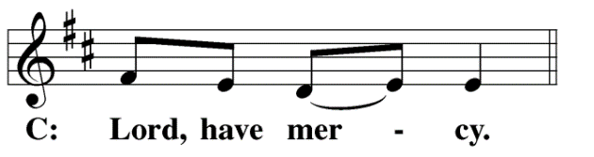
M: For the steadfast assurance that nothing can separate us from your love and for the courage to stand firm against the assaults of Satan and every evil, hear our prayer, O Christ.
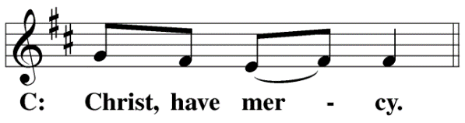

M: For the well-being of your holy Church in all the world and for those who offer here their worship and praise, hear our prayer, O Lord.
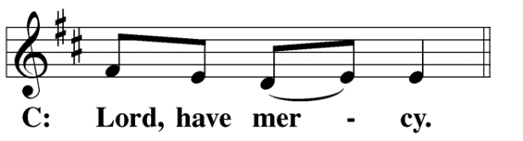
M: Merciful God, maker and preserver of life, uphold us by your power and keep us in your tender care:
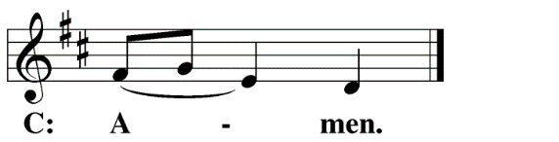
M: The works of the Lord are great and glorious; his name is worthy of praise.
O LORD, OUR LORD
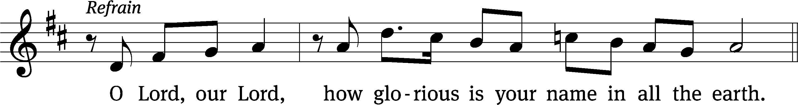
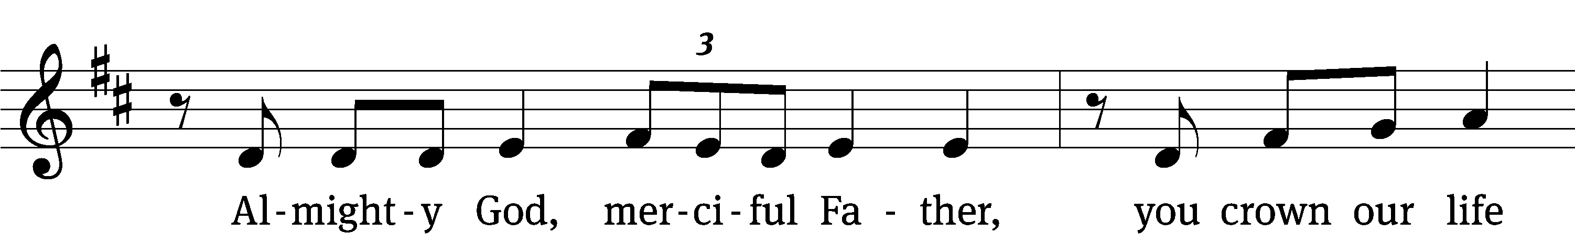
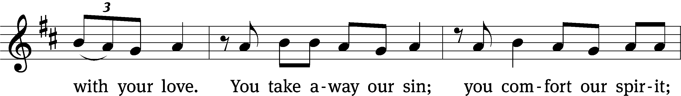
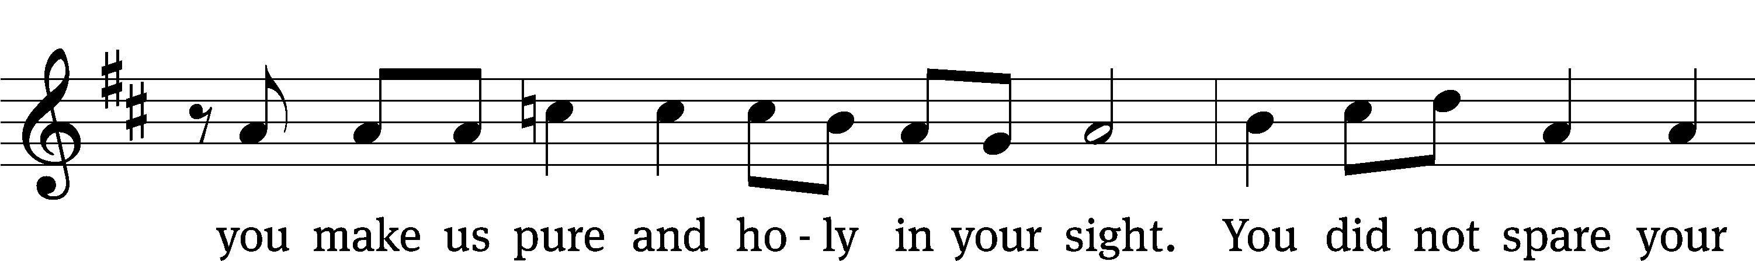
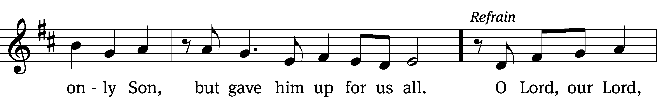
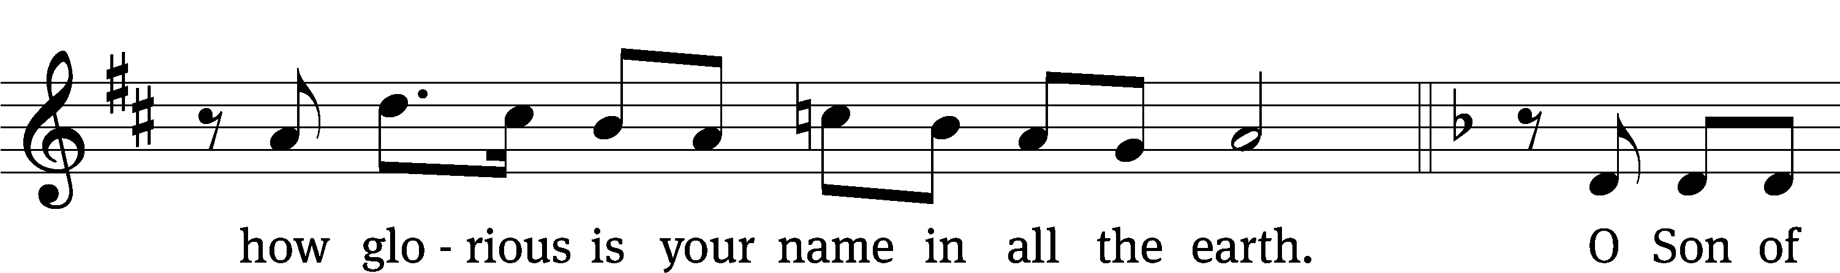
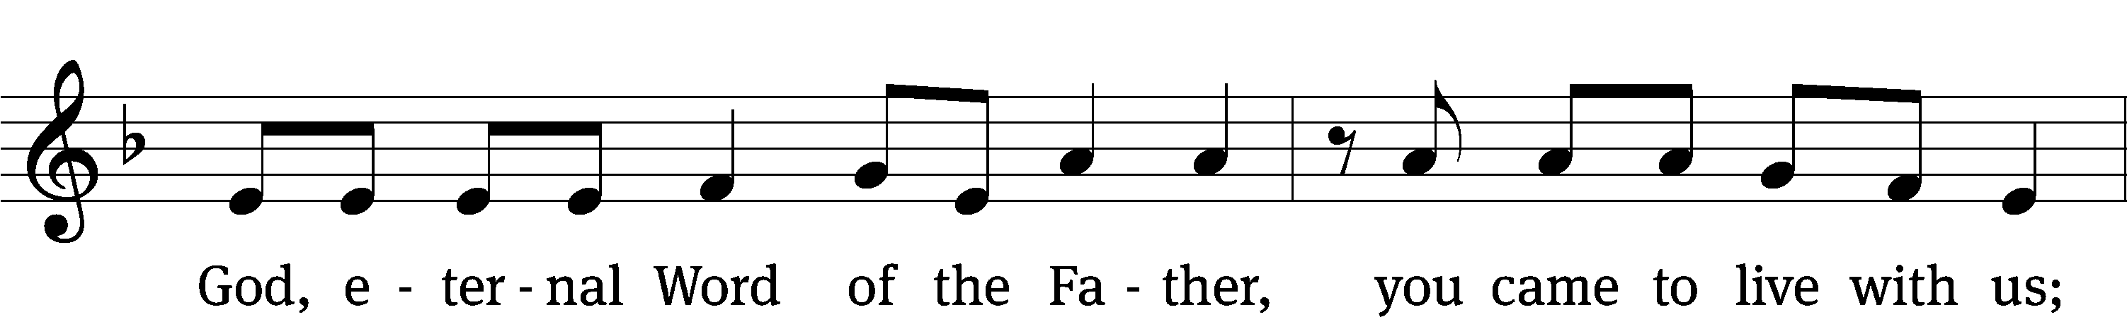
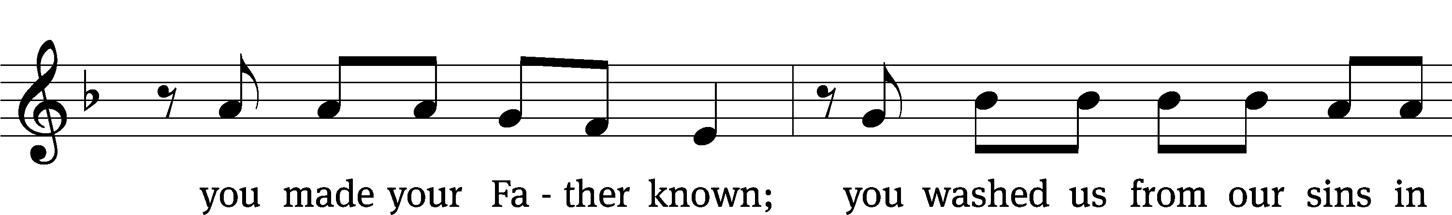
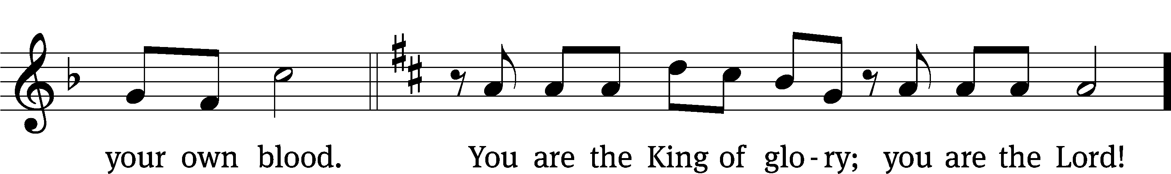
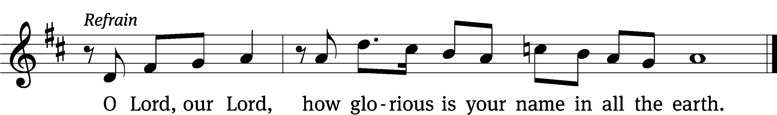


The Service of the Word
Having just received absolution for their sins, believers now gather around the Word of God to find encouragement and peace for their lives on earth.
PRAYER OF THE DAY
M: Let us pray.
O God, by the humiliation of your Son, you lifted up this fallen world from the despair of death. By his resurrection to life, grant your faithful people gladness of heart and the hope of eternal joys; through your Son, Jesus Christ our Lord, who lives and reigns with you and the Holy Spirit, one God, now and forever.
C: Amen
FIRST LESSON Acts 2:14a,32–41
Peter’s Pentecost Sermon: Jesus Christ has been exalted to the Father’s right hand.

Then Peter stood up with the Eleven, raised his voice and addressed the crowd: “Fellow Jews and all of you who live in Jerusalem, let me explain this to you; listen carefully to what I say.
God has raised this Jesus to life, and we are all witnesses of it. Exalted to the right hand of God, he has received from the Father the promised Holy Spirit and has poured out what you now see and hear. For David did not ascend to heaven, and yet he said,
“‘The Lord said to my Lord:
“Sit at my right hand
until I make your enemies
a footstool for your feet.”’
“Therefore let all Israel be assured of this: God has made this Jesus, whom you crucified, both Lord and Messiah.”
When the people heard this, they were cut to the heart and said to Peter and the other apostles, “Brothers, what shall we do?”
Peter replied, “Repent and be baptized, every one of you, in the name of Jesus Christ for the forgiveness of your sins. And you will receive the gift of the Holy Spirit. The promise is for you and your children and for all who are far off—for all whom the Lord our God will call.”
With many other words he warned them; and he pleaded with them, “Save yourselves from this corrupt generation.” Those who accepted his message were baptized, and about three thousand were added to their number that day.
PSALM Psalm 116
SECOND LESSON 1 Peter 1:17–21
Redeemed by Christ, we live as strangers in this world.
Since you call on a Father who judges each person’s work impartially, live out your time as foreigners here in reverent fear. For you know that it was not with perishable things such as silver or gold that you were redeemed from the empty way of life handed down to you from your ancestors, but with the precious blood of Christ, a lamb without blemish or defect. He was chosen before the creation of the world, but was revealed in these last times for your sake. Through him you believe in God, who raised him from the dead and glorified him, and so your faith and hope are in God.

VERSE OF THE DAY Luke 24:32
M: Alleluia, Alleluia. Christ is risen!
C: He is risen, indeed! Alleluia!
M: Were not our hearts burning within us while he talked with us on the road and opened the Scriptures to us?
C: Alleluia.
THE GOSPEL Luke 24:13–35
The key to the Scriptures: the Messiah must suffer and die.
Now that same day two of them were going to a village called Emmaus, about seven miles from Jerusalem. They were talking with each other about everything that had happened. As they talked and discussed these things with each other, Jesus himself came up and walked along with them; but they were kept from recognizing him.
He asked them, “What are you discussing together as you walk along?”
They stood still, their faces downcast. One of them, named Cleopas, asked him, “Are you the only one visiting Jerusalem who does not know the things that have happened there in these days?”
“What things?” he asked.
“About Jesus of Nazareth,” they replied. “He was a prophet, powerful in word and deed before God and all the people. The chief priests and our rulers handed him over to be sentenced to death, and they crucified him; but we had hoped that he was the one who was going to redeem Israel. And what is more, it is the third day since all this took place. In addition, some of our women amazed us. They went to the tomb early this morning but didn’t find his body. They came and told us that they had seen a vision of angels, who said he was alive. Then some of our companions went to the tomb and found it just as the women had said, but they did not see Jesus.”
He said to them, “How foolish you are, and how slow to believe all that the prophets have spoken! Did not the Messiah have to suffer these things and then enter his glory?” And beginning with Moses and all the Prophets, he explained to them what was said in all the Scriptures concerning himself.
As they approached the village to which they were going, Jesus continued on as if he were going farther. But they urged him strongly, “Stay with us, for it is nearly evening; the day is almost over.” So he went in to stay with them.
When he was at the table with them, he took bread, gave thanks, broke it and began to give it to them. Then their eyes were opened and they recognized him, and he disappeared from their sight. They asked each other, “Were not our hearts burning within us while he talked with us on the road and opened the Scriptures to us?”
They got up and returned at once to Jerusalem. There they found the Eleven and those with them, assembled together and saying, “It is true! The Lord has risen and has appeared to Simon.” Then the two told what had happened on the way, and how Jesus was recognized by them when he broke the bread.

M This is the Gospel of the Lord.
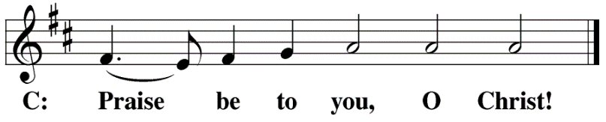
HYMN OF THE DAY Christ the Lord is Risen Again| CW 459
SERMON Luke 24
NICENE CREED
Having heard the Word of God, we confess our faith in His name. The creed is our saying back to God what He has first said to us. In the Creed we acclaim the truth of the triune God and His work of salvation accomplished for us in His incarnate Son, Jesus Christ.
We believe in one God, Dt. 6:4
the Father, the Almighty, 2 Cor. 6:18
The Nicene Creed is the great Confession of the Christian faith professed by all Christians. The Creed originated at the First Council of Nicaea (c. AD. 325)
maker of heaven and earth, Is. 51:13
of all that is, seen and unseen. Col. 1:16
We believe in one Lord, Jesus Christ, 1 Cor 8:6
the only Son of God, Jn. 3:16
eternally begotten of the Father, Heb. 1:2,5
God from God, Light from Light, true God from true God, Jn. 1
begotten, not made, of one being with the Father. Jn. 10:30
Through him all things were made. Jn. 1:3
For us and for our salvation, 1 Th. 5:9
he came down from heaven, Jn. 6:38
was incarnate of the Holy Spirit and the virgin Mary, Lk. 1:35
and became fully human. Gal. 4:4
For our sake he was crucified under Pontius Pilate. Mk. 15:15
He suffered death and was buried. 1 Cor. 15:3-4a

On the third day he rose again in accordance
with the Scriptures. 1 Cor. 15:4b
The Creed itself was crafted as a confession of Scripture in opposition to the Arian heresy, which denied that the Lord Jesus and the Holy Spirit are God.

He ascended into heaven Ac. 2:33-34
and is seated at the right hand of the Father. Heb. 1:13
He will come again in glory Mt. 25:31
to judge the living and the dead, 2 Tim. 4:1
and his kingdom will have no end. Lk. 1:33
We believe in the Holy Spirit, the Lord, the giver of life, Job 33:4
who proceeds from the Father and the Son, Jn. 15:26
who in unity with the Father and the Son Jn. 4:24
is worshiped and glorified,
who has spoken through the prophets. 2 Pet. 1:25
We believe in one holy Christian Mt. 16:18; Eph. 2:19-20
and apostolic Church.
We acknowledge one baptism for the forgiveness of sins. Eph. 4:5; Ac. 2:38
We look for the resurrection of the dead 1 Cor. 15:21-22
and the life of the world to come. Amen. Rev. 22

OFFERING
In response to God’s love and forgiveness, we give back a portion of what he has given us. The members of Christ Lutheran Church have joined to proclaim the gospel to this community. These offerings support that work. While our guests are welcome to participate, they should not feel obligated to do so.
PRAYER OF THE CHURCH
M: God of all compassion, Your Spirit opens the Holy Scriptures to the hearts of Your people. Enlighten us by the resurrection light that never fades.
C: Warm our hearts with understanding by your Word.
M: Blessed Lord, You have established Your Church so that Your promise of eternal life might be delivered to us, to our children and to all who are far off — to everyone whom the Lord our God calls to Himself. Grant us faithful pastors to proclaim repentance and forgiveness through Word and Sacrament.
C: Make their hearts burn within them to serve your people and proclaim your gospel.
M: O Lord, grant that Your Word may be the foundation of every Christian home; that husbands and wives may be united in faith and hope; and that children may hear and be nurtured in this Word by faithful parents.
C: Grant the warmth of your love among all families.
M: Almighty God, stifle the powers of darkness and end the reign of war, violence and terror. Give leaders who will seek peace and work for the common good. Instill in them a love of righteousness, and guide them in the pursuit of justice for all. Bless Donald, our president; the Congress of the United States; Gavin, our governor; all state and local officials; all medical and emergency workers; and all members of the armed forces.
C: May the light of redemption shine on all nations.
M: O God, You have not forgotten us in our afflictions or abandoned us in our weakness. Deliver the sick and suffering according to Your will, and give comfort to the dying, especially to those who have requested our prayers [including _____________]. Guard us against despair, and grant us patience in days of trouble as we await Your perfect healing.
C: Stay with us in the darkness of our cross and afflictions.
M: Merciful Lord, Your compassion is made known to us through Your Son’s breaking of the bread. Open our hearts and mouths to receive forgiveness in the body and blood of Christ, who suffered for us and has entered into His glory.
C: Though we do not see this miracle, assure us of Your Son’s presence.
M: These things and whatever else You know that we need, kind Father, grant us for the sake of Your beloved Son, Jesus Christ, who lives and reigns with You and the Holy Spirit, one God, now and forever.
C: Amen.

LORD’S PRAYER Matthew 6:9-13; Luke 11:2-4
C: Our Father, who art in heaven, hallowed be thy name,
thy kingdom come, thy will be done on earth as it is in heaven.
Give us this day our daily bread; and forgive us our trespasses,
as we forgive those who trespass against us;
and lead us not into temptation, but deliver us from evil.
For thine is the kingdom and the power and the glory
forever and ever. Amen.

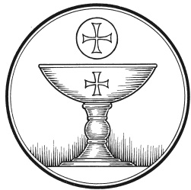
The Service of the Sacrament
This greeting marks a new service, so to speak. These ancient introductory words & phrases help to highlight, celebrate and bring attention to the Sacrament.
M: The Lord be with you.
C: And also with you.
M: Lift up your hearts.
C: We lift them up to the Lord.
M: Let us give thanks to the Lord our God.
C: It is right to give him thanks and praise.
M: Praise to the God and Father of our Lord Jesus Christ! In love he has blessed us with every spiritual blessing. iHe raised Christ from the dead and seated him at his right hand in the heavenly realms and placed all things under his feet for the benefit of the Church. Now have come the salvation and the power and the kingdom of our God and the authority of his Christ. To him who sits on the throne and to the Lamb be praise and thanks and honor and glory for ever and ever:
HOLY, HOLY, HOLY – Sanctus
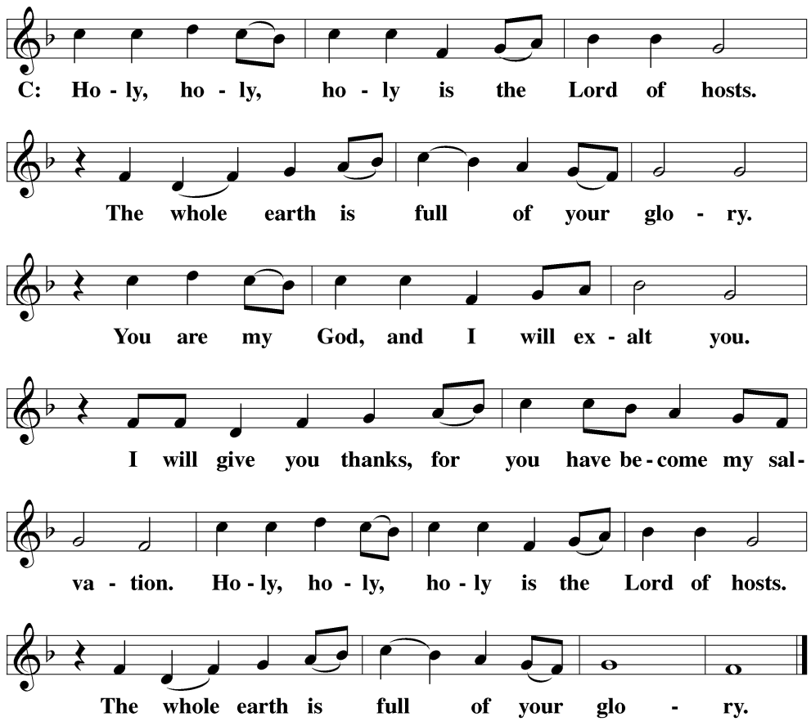

WORDS OF INSTITUTION Matthew 26, Mark 14, Luke 22
M: Our Lord Jesus Christ, on the night he was betrayed, took bread; and when he had given thanks, he broke it and gave it to his disciples, saying: “Take and eat. This is my ✙ body, which is given for you. Do this in remembrance of me.”
The Words of institution both proclaim the words of Jesus to the congregation and sets apart the bread and wine for the Lord’s Supper.
Then he took the cup, gave thanks, and gave it to them, saying, “Drink from it all of you; this is my ✙ blood of the new covenant, which is poured out for you for the forgiveness of sins. Do this, whenever you drink it, in remembrance of me.”

PEACE OF THE LORD – Pax Domini John 20:19
M: The peace of the Lord be with you always.
C: Amen

O CHRIST, LAMB OF GOD – Agnus Dei John 1:29
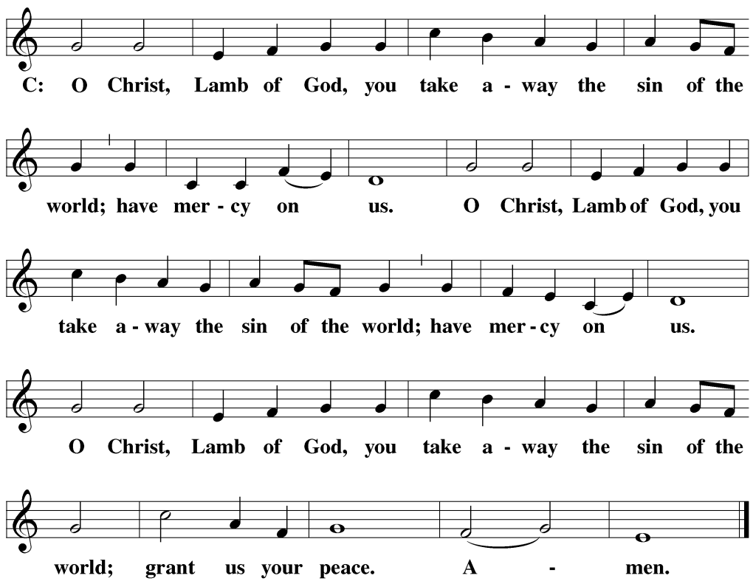
DISTRIBUTION
Those who will be receiving Holy Communion today may wish to read Personal Preparation for Holy Communion, found on page 295 in the front section of the hymnal. This page helps us put into practice what the Bible encourages: “Everyone ought to examine themselves before they eat of the bread and drink from the cup.” (1 Corinthians 11:28)
Christ Lutheran Church confesses and practices the Biblical teaching of a Closed Communion. We ask that only members of the Wisconsin Synod [WELS] or the Evangelical Lutheran Synod [ELS] join us at the Lord’s Table. If you have questions concerning our communion practice, or would like to inquire about how you, too, can commune with us, please speak with the Pastor following the service.
During the Distribution, the congregation may join to sing Hymn 660:
Here, O My Lord, I See You Face to Face
before or after they receive the Sacrament.
M: Hear the prayer of your people, O Lord, that the lips which have praised you here may glorify you in the world, that the eyes which have seen the coming of your Son may long for his coming again, and that all who have received in his true body and blood the pledge of your forgiveness may be restored to live a new and holy life, through Jesus Christ, our Lord, who lives and reigns with you and the Holy Spirit, one God, now and forever.
C: Amen.
THE BLESSING
M: The Lord bless you and keep you.
The Lord make his face shine on you and be gracious to you.
The Lord look on you with favor and ✙ give you peace.
C: Amen.

CLOSING HYMN Crown Him With Many Crowns| CW 511

COPYRIGHT INFORMATION
Content requiring a copyright license is reproduced under OneLicense.net #A-718312. All rights reserved. The Common Service: Texts revised from The Lutheran Hymnal, 1941. Music revised by James Engel. Scripture Quotations: From the Holy Bible, New International Version (NIV 1984), © 1973, 1978, 1984 by Biblica, Inc.

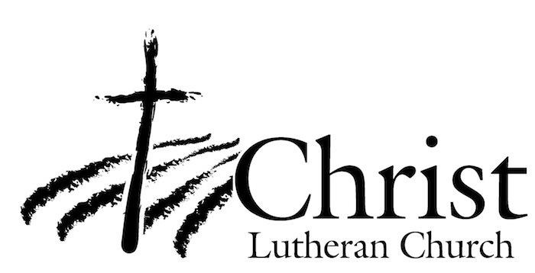
13009 N. Elderberry Ct.
Lodi, CA 95242
www.christlodi.org
209-368-6250
Pastor Timothy Leistekow
WELCOME TO CHRIST EV. LUTHERAN CHURCH!
We preach a message of forgiveness, hope and peace
through the death and resurrection of Jesus Christ.
Families and individuals of all ages will find opportunities
both to grow and to serve.
Our mission statement:
Look what Christ is doing!
He binds us together in fellowship
He gathers us in for worship
He builds us up for service
He sends us out with the gospel

“Now you are the body of Christ,
and each one of you is a part of it.”
(1 Corinthians 12:27)

